Name: ________________________________ Date: ________________ Period: ________
The Stunt Car Challenge v. 2.0!
Part I – The Stunt Car Challenge
Materials:

- Spring loaded “pull-back” car
- Jump track ramp assembly (with photogate)
- Computer or LabQuest
- 3 angle wedges
- Measuring tape
- Protractor
- Calculator
- Fish net or method for catching the car

Background:
The goal is to systematically let the car accelerate up the ramp and use the vertical and horizontal components of its initial velocity to measure the endpoint of its jump. You will use one or more wooden wedges to vary the angle of the ramp (approximately, 10º, 20º, and 30º). Before you can conduct your experiments, however, you will need to determine the velocity of your car as it leaves the ramp.
Before you launch your car, your partner must prepare to catch the car as it leaves the ramp using the fish net or other catching method. The photogate will record the time that the entire toy car body passes through the photogate. The resulting velocity of the car can be found by calculating the length of the toy car divided by the time the car takes to pass through the photogate (v = d/t).
For the pull-back race car to provide an accurate average launch speed for each trial, you will need to develop a consistent technique for operating your vehicle. Start your wind-up and release from the same locations. It is important to launch the car from the SAME starting position each time! Have your partner ready to catch the car EACH TIME just as it exits the ramp. The car operates by carefully and gently pushing down on the car and pulling back until you hear a click. Make sure the wheels don’t spin for consistent measurements. When you are ready to launch, release the car (or tap it lightly on the roof) and it will accelerate down the track.
Warning: Please be gentle with the pull-back cars
They will not tolerate rough handling and will break if repeatedly allowed to drop to the floor
Procedure:
- Set your launch angle(s) assigned by your teacher using the wooden wedge(s) in the launch track and measure the actual angle of the track from the horizontal to provide accuracy in your calculations.
- Attach the power cord and the connecting cable from the photogate to the LabQuest or LabPro, or computer station.
- Turn on your data collection software to activate the photogate. Now you are ready to launch your car to determine its speed at the end of the launch track.
- Prepare to catch your vehicle before your launch.
- Press the play button to begin data collection and launch the car five times through the photogate.
- Change the view to the data table and find the time for each trial by subtracting each blocked (white) time from the unblocked time (blue). Record these times in seconds.

Time measured by the photogate in seconds:

Trial #1 ____________________________s
Trial #2 ____________________________s
Trial #3 ____________________________s
Trial #4 ____________________________s
Trial #5 ____________________________s

Are the times consistent? If not, did the photogate record any extra events? Should those times count?

- Calculate your average time through photogate: _______________________seconds

- Use the protractor to measure your team’s launch angle: __________degrees

- What is the length of your toy car (in meters): ______________m

Calculations (begin with the appropriate equation and show your work):
- Calculate the initial velocity (v_{i}) of your car in meters/second as it leaves the ramp using the following equation: v_{i} = car length/average photogate time: _____m/s

- Calculate the horizontal component of the v_{i}: v_{ix} = ___________ m/s
Hint: Look at the equation page!

- Calculate the vertical component of the v_{i}: v_{iy} = ________ ____m/s
Hint: Look at the equation page!

- A) Find the change in vertical velocity from the launch to the top of the car’s path.:
____________m/s

B) Calculate the total time of flight for your toy car: _________ s

- Calculate the horizontal distance your car will travel: __________ m

- Calculate the maximum vertical height your car will travel: m
Hint: The time it takes to get to the maximum height is half of your total travel time.

- Label the diagram with your calculated values for the following
- launch angle
- initial velocity of your car
- your calculated prediction of the car’s horizontal distance
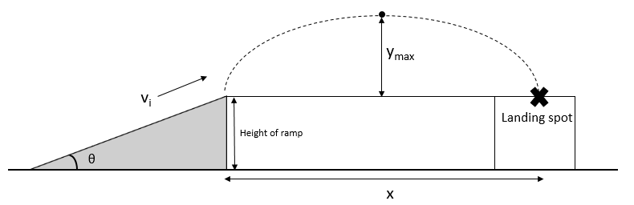
- your calculated prediction of the car’s maximum vertical height

And Now…. The True Test:
- When you have all of your calculated values, call your teacher over to test your predictions.
- Launch the car from the SAME starting position as in the earlier trials and observe the mark made by the car striking the paper on the landing pad. If the car hits the paper, there should be a mark on the paper where your partner can measure the actual horizontal distance the car traveled. Record this distance below.
Calculated Horizontal Distance (meters) __________

Experimental Horizontal Distance (meters) __________

- Calculate the Percent Error between the calculated horizontal distance (Calc) and your experimental horizontal distance (Exp) using the equation below:
$$\% Error =\frac{Exp-Calc}{Calc}x 100\%$$

- If there was significant error, discuss some of the factors attributing to the fluctuations in the values?

Part II – The “Movie Question:”
In the movie “Speed” a bus must jump a gap in an unfinished highway. The bus just makes it, but are the movie makers accurate? Use the given data from the movie clip and your newly gained knowledge of projectile motion to find out if the bus should make it or fall short into disaster.
How far would the bus make it? (Find x or d_{x} or d_{h.}) Show your calculations.

Hint: Metric units to English unit conversions
$meters per second=\frac{miles per hour}{2.2}$ $1 meter=3.28 feet$
Movie Facts:
Launch velocity (v_{i}) of bus: 68 mph
Launch angle: 5°
Length (d_{h}) of “gap” in road: 109 ft

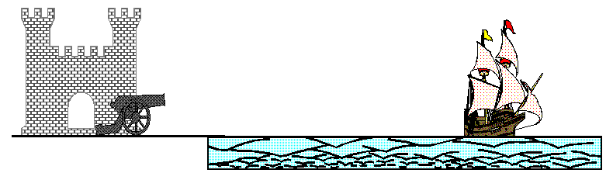
Part III Additional Questions:
1. A cannon is fired at 100 m/s at an angle of 30 degrees. Find the:
a. time in the air
b. maximum height of the cannonball
c. how far the cannonball travels horizontally

2. Using a six-iron (45º loft) and the same launch velocity as on Earth (70 m/s), how far horizontally did Apollo 14 Astronaut Alan Shepard drive a golf ball on the Moon? [Hint… to find the time of flight, use a =g = 1.6 m/s² for the Moon.]
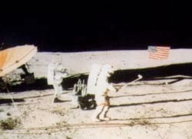
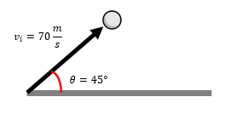

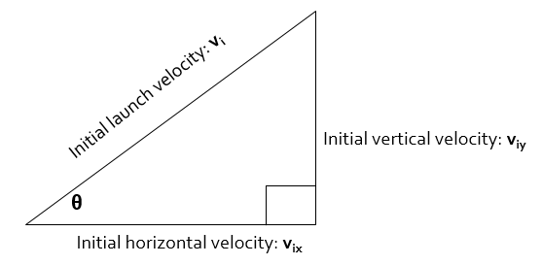
Useful Equations and Information for Students Participating in the Stunt Car Challenge
$$distance=d$$
$$horizontal displacement=x=d_{x}=d_{h}$$
$$vertical displacement=y=d_{y}=d_{v}$$
$$initial launch velocity=v_{i}$$
$$horizontal component of launch velocity=v_{ix}=v_{ih}$$
$$vertical component of launch velocity=v_{iy}=v_{iv}$$
$$the acceleration in the horizontal direction=zero$$
$$the acceleration a in the vertical direction=the gravitational constant g=-9.80\frac{m}{s^{2}}$$
$\sin{θ}=\frac{opposite}{hypotenuse}=\frac{v_{iy}}{v_{i}}$ $\cos{θ}=\frac{adjacent}{hypotenuse}=\frac{v_{ix}}{v_{i}}$
General equation for projectile motion | $$d=v{}_{i}t+\frac{1}{2}at^{2}$$
Vertical displacement only | $$y=v{}_{iy}t+\frac{1}{2}gt^{2}$$
or | $$d_{y}=v{}_{iy}t+\frac{1}{2}gt^{2}$$
or | $$d_{v}=v{}_{iv}t+\frac{1}{2}gt^{2}$$
Horizontal displacement only | $$x=v_{ix}t$$
or | $$d_{x}=v_{ix}t$$
or | $$d_{h}=v_{ih}t$$
Time up to maximum height or time down from maximum height | $$t=\frac{v_{fy}-v_{iy}}{g}=(∆v_{y})/g$$
or | $$t=\frac{v_{fv}-v_{iv}}{g}=(∆v_{v})/g$$
Total time of flight from launch to landing | $$total time t=2\left(\frac{∆v_{y}}{g}\right)$$

Name: ________________________________ Date: ________________ Period: ________

Part IV: LAUNCHING PROJECTILES
Introduction:
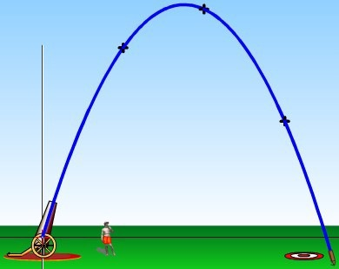
We see examples of Projectile Motion in every aspect of our lives; the kick of a football, a home run in baseball, a 9-iron golf shot, or a stunt driver driving his car off a ramp. In this lab, you will find out how projectiles aimed at different angles behave and use real-world applications to confirm your calculations of distances and times.
Part I - Projectile Motion Simulator
Materials (per student team):
- Computer with internet access
- Calculator
Procedure:
At your computer, open the Projectile Motion simulation:
http://phet.colorado.edu/simulations/projectilemotion/projectile.swf
Experiment with factors that affect the flight of your projectile including the:
- height of the cannon
- location of the cannon
- angle of the cannon
- initial speed of the projectile
- air resistance
- range, height and time during the flight

- Use the tape measure in the simulation to test your own ideas about the things that affect the landing spot of a projectile.
- Experiment with different projectiles (tank shell, golf ball, baseball, bowling ball, football, pumpkin, adult human, piano or Buick) provided.
- Become familiar with the simulation and its controls. Vary ONE variable at a time to determine how that variable affects the projectile’s motion (how far it goes, how high it goes, how long before it hits the ground, etc.).
- Proceeding through the simulation, answer the following questions by experimenting with the variables in the “green” box. You can either type in the angle you desire or click on the cannon and the tape measure to vary distances, heights, etc.
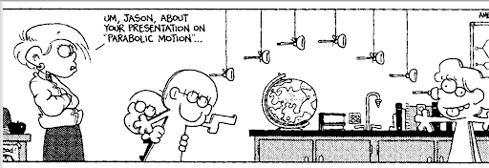
(reprinted with permission from Bill Amend)

Questions:
- Keeping the “Initial Speed” and “Projectile Type” constant and the “Air Resistance” unchecked, what angle results in the longest horizontal distance?

- Keeping the “Initial Speed” and “Projectile Type” constant and the “Air Resistance” unchecked, what angle results in the highest vertical distance?

- Keeping the “Initial Speed” and “Projectile Type” constant and the “Air Resistance” unchecked, launch a projectile at 30º. What angle results in the same horizontal distance?

- Keeping the “Initial Speed” and “Projectile Type” constant and the “Air Resistance” unchecked, launch a projectile at 75º. What angle results in the same horizontal distance?

- What “rule” could you make concerning the launch angle and the resulting horizontal distance?

- Sketch the path of a true projectile (no air resistance) fired at 50º. What shape is it?

- How does the mass of a projectile affect the horizontal distance if fired at the same initial speeds?

- Fire a projectile of your choice at 45º. Leave the traced path on the simulation. Turn on the “Air Resistance”. Fire the same projectile at the same angle. What happens to the vertical and horizontal distances?

- What angle should you launch a projectile to make it travel the farthest horizontal distance with air resistance?

- Now the situation changes, and the launching position and landing position are NOT on the same level. The projectile will land BELOW the original launch height. For our last experiment with the simulation, set the following conditions PRIOR to firing…(No air resistance).
  - Set the angle to 65º.
  - Select the “Buick” projectile
  - Set the Initial Speed to 20 m/s
  - Show your work for the calculations below:

  - Calculate the total time of flight. _______ seconds

  - Calculate the vertical height of the Buick at its highest point of its trajectory. _______m

  - Calculate the horizontal distance the Buick travels. _______m

- Before you “fire” the Buick, set the red target where you have pre-calculated it should land. Now launch… “FIRE IN THE HOLE!”

