6/2006

Purdue University Light Sensor and
UVA, UVB Sensors

Purdue University Science Express

AN EXPERIMENT TO INVESTIGATE
THE RELATIONSHIP BETWEEN ILLUMINATION AND DISTANCE
and
ULTRAVIOLET EMISSIONS OF
HOUSEHOLD LIGHT BULBS

Please read me first:

The Vernier manual Physics with Calculators provides two excellent procedures for the use of light sensors. Lab 31 investigates the Polarization of Light and Lab 32 studies Light, Brightness and Distance. HOWEVER, the Vernier manual for Lab 32 did not discuss the relationship between light and distance from the source in a way that we thought would work best for our students.The printed procedure and its software have students collect individual data points in which they use software and the resulting graph to see illumination at only certain distances. We preferred to record the illumination over a period of time at a variety of distances in real time, so that our students could see how dramatically the illumination changed as the bulb physically moved from one position to another. The following procedure which we developed describes how to record Illumination vs. Time, with the experimenter physically moving the source from location to location while data is still being collected. This method requires students and teachers to choose appropriate distances from the source before data is actually collected, so there is an element of investigation and inquiry before the actual experiment begins.

The Vernier manual provides very clear instructions for making connections and using the software. We recommend the purchase of this manual.
6/2006
Purdue University Science Express

AN EXPERIMENT TO INVESTIGATE
THE RELATIONSHIP BETWEEN ILLUMINATION AND DISTANCE
and
ULTRAVIOLET EMISSIONS OF HOUSEHOLD LIGHT BULBS

INTRODUCTION:

Which is a better purchase--a 25 W compact fluorescent bulb or a 25 W incandescent bulb? Which provides more light onto your desk? Which costs more to operate? Does either bulb emit harmful ultraviolet radiation? Which generates more waste heat as infrared radiation? These questions should concern smart shoppers and consumers. And the answers to those questions depend upon your needs and lifestyle.
Illumination on a surface like a table or desk is measured in units called lux while the brightness of the source itself, the intensity, is measured in units called lumens. In detail, 1 lux = 1 lumen per meter². However, most people do not care about the distinction between the two. We even buy light bulbs in units of watts, which is the unit for the power that is required to operate the bulb. We REALLY should purchase bulbs based on the lumens of light (the intensity again) that they can provide. In this experiment, while it LOOKS like we are measuring intensity, we are REALLY measuring illumination on the surface of the light sensing probe. We may use the words interchangeably, but real Physics folks would be specific about the difference between the terms.
Imagine you have darkened your living room until only one lamp remains lit. If you then step away from the lamp, you immediately notice how the brightness changes as you move away from the bulb. Scientists consider the bulb to be a point source, emitting light three dimensionally, like a light bulb might if it were in the middle of a expanding bubble. At any instant of time, the bubble’s surface is the illumination at that instant of time. As the radius of the bubble increases, the surface area of the bubble increases but the intensity of the bulb itself hasn’t changed. The brightness you are able to detect at increasing distances from the source will change. Light fixtures must be designed to provide adequate and appropriate amounts of light for the environments where they will be used: a nightlight bulb is not right for illuminating a football field!
The actual light that a bulb produces may include a portion of the electromagnetic spectrum even larger than the range we think of as visible light. Bulbs may produce visible light, but infrared (commonly called heat) and ultraviolet energy can also be emitted. In fact, some bulbs produce more electromagnetic radiation in the infrared and ultraviolet portions of the spectrum than they do in the visible. These radiations are useless to you if you are planning for the bulb to produce light to help you see.

PURPOSE:
In this experiment we will measure some factors which may be a part of light bulb selection. We will measure the illumination that different household light bulbs provide at different distances from the source. We will record the amount of illumination that can be detected through different colored filters. We will also check for the emission of ultraviolet A and ultraviolet B rays from these bulbs. We will discuss the results.

PROCEDURE:

MATERIALS PER GROUP:

meter stick
light bulb socket base with pull chain, such as the kind from Sargent Welch
typical light bulbs with medium bases, of various styles and wattages:
frosted, clear, incandescent, compact fluorescent, fan bulbs, etc.
2 ring stands
2 right angle clamps or 2 utility clamps and 2 right angle clamps
lightweight cotton canvas gloves, to be worn while changing light bulbs; or
Chemistry “Hot Hands” or dry folded paper towels to be used as a
“pot holder” on warm light bulbs

colored filters or cellophane: red, blue, green, saran wrap, waxed paper

Vernier Light Sensor
Vernier UVA and UVB sensors
computer with Logger Pro 3 software
Lab Pro Interface

PROCEDURE Part A, the Light Sensor

1. Connect the computer to Lab Pro Interface. Connect the Vernier light sensor to Lab Pro Interface in channel 1. Set the range switch on the sensor itself to 6000 lux. Open the Logger Pro 3 software and note that the sensor has been found by the computer and software. The data table and blank graph which are displayed should be labeled with time and illumination.

2. Attach the clamps to the ring stand; then firmly but gently secure the light sensor so that it is parallel to the table top and so that its photosensitive tip is able to point directly at the light bulb. Arrange the equipment so that the filament of the bulb is in a line with the tip of the sensor.

3. Place the meter stick so that the 0 cm mark is directly beneath the tip of the sensor and so that the light bulb in its holder is at the 25 cm mark. As the equipment proceeds, you will be moving the bulb farther and farther from the sensor along the meter stick. You will move the bulb to the 50 cm, 75 cm, and 100 cm positions.

4. Minimize nearby glare with large sheets of paper, books, or other light-absorbing materials.

5. Dim the room lights and prepare to Collect data.

6. As you Collect data, allow the sensor enough time at each measured distance so that you will be able to get a representative sample of consistent data at that distance. The amount of time is not crucial. Try to keep the times approximately equal. Every graph should show a region of constant illumination at each particular distance between bulb and source. (Since you used four distances, you should have four “plateaus” on your graph.)

7. Once data is collected at the 25 cm, 50 cm, 75 cm, and 100 cm marks for a particular bulb, Save your results. Remember to write down the name you use for this saved file.

8. Unplug the bulb and allow it to cool. CAUTION: BULBS CAN BE HOT AND CAN CAUSE BURNS! TELL YOUR TEACHER IMMEDIATELY IF YOU ARE BURNED!

Your teacher may suggest lightweight cotton gloves, a Chemistry class “Hot Hands” or a folded and dry paper towel to be used as a “pot holder” for any warm light bulbs.

9. Once you have saved the results, Analyze the graph. Choose Analyze, Statistics. Mark the region of the graph you want to study by clicking and dragging across the curve--special brackets will appear to mark the region you are considering. You will be able to see the mean value of Illumination at each distance. Save once again (this time you are saving data, graph, and your analysis statistics).

10. Move the bulb to the 50 cm mark, turn it on, and choose Experiment, Collect Data or just click on the Collect button.

11. Repeat the process of moving the bulb, collecting and analyzing data, and saving your work until all distances between source bulb and sensor have been measured.

12. Change bulbs and repeat the entire procedure again until you have as many bulbs as your teacher directs you to use.

13. Record your data and complete Data Table #1.

Part B, the Light Sensor and Colored Filters

14. Remove the previous bulb and replace it with the first bulb you tested. Replace the bulb holder at the 25 cm mark.

15. Prepare to place colored cellophanes directly over the tip of the sensor, so that light from the bulb must pass through the colored cellophane in order to reach the probe. Record the order in which you plan to use the colors.

16. Prepare to Collect data and work quickly. The length of time for each colored filter is not important, but the quality of consistent illumination for each color is important.

17. Collect data for the illumination through each colored filter. Be sure all information fits on one graph. Save.

18. Choose Analyze and Statistics. Use the cursor to mark a portion of the graph which represents consistent illumination data for each colored filter you used. Record the mean amount of illumination that is possible with each colored filter in Data Table #2.

PROCEDURE Part C, the UVA and UVB Light Sensors

19. Remove the Light Sensor from channel 1. Insert the UVA Sensor in channel 1 and insert the UVB sensor into channel 2. Be sure the software has located the sensors. You should see that you will be recording data from BOTH sensors at the same time. The data table will have columns for time and UVA and UVB. Collect light briefly and note the approximate amount of UVA and UVB being recorded. You may need to resize the axes of the graphs before you begin to collect actual data.

20. Choose two bulbs of equal wattage. One bulb should be clear glass and the other frosted glass. Both bulbs should have the same shape. Place first bulb in socket holder and turn it on.

21. Use the clamps to attach and position both of the UV Sensors side-by-side, parallel to the floor, facing the light bulb. Be sure the meter stick is in position with the 0 cm mark directly below the tips of the sensors. Position the first bulb at the 25 cm mark.

22. Dim the room lights and prepare to Collect data. Collect data.

23. Save this trial. Choose Analyze and Statistics. Note the mean amount of illumination for UVA and UVB.

24. Record the data in Data Table #3.

25. Remove the first bulb and change to the other bulb. Repeat the procedure to record the UVA and UVB provided by this second bulb. Record in Data Table #3.

SAFETY:

1. Students should observe all laboratory safety precautions, including the wearing of appropriate clothing, footwear, and safety goggles.

2. There should be no eating or drinking during the experiment.

3. Light bulbs can be hot and can cause burns! Follow your teacher’s instructions for letting the bulbs cool or for handling warm bulbs.

4. Wash hands thoroughly after clean-up.

5. When the experiment is finished, be sure all materials are repackaged according to Science Express specifications and notify Science Express of any problems with equipment or samples.

PRELAB QUESTIONS:

1. Draw and label the electromagnetic spectrum. Color the portion which represents visible light. Add the approximate values of frequency and wavelength to this sketch.

2. Write a hypothesis describing relationship between illumination and distance between source and surface.

3. In the portion of the experiment where you will use colored filters, which color(s) do you predict will be brightest? How will you tell?

4. What predictions do you have about the ultraviolet portion of the experiment?

5. List the types of light bulbs you have in your home. List the typical wattages of light bulbs in your home.

.
DATA TABLE 1.

 | mean illumination (lux) for 75 W bulb | mean illumination (lux) for 60W bulb | mean illumination (lux) for 11W bulb | mean illumination (lux) for___W bulb | mean illumination (lux) for ___ W bulb
frosted or clear?
tubular or not?
distance (cm)
25
50
75
100

DATA TABLE 2.

distance bulb to probe (cm) | color | mean illumination (lux) of 75 W bulb
25 cm
25 cm
25 cm
25 cm
25 cm

DATA TABLE 3.

 | bulb 1 | bulb 2
watts of bulb??
clear or frosted?
mean amount UVA (mW/m^2)
mean amount UVB (mW/m^2)

ANALYSIS AND CONCLUSIONS. Use complete sentences.

1. Make one graph of Illumination vs. Distance. Place all sets of data on one set of axes. Save and print your graphs.

2. What happens to the illumination as the distance increases between the light source and the probe?

3. Modify the data so that you generate a best-fit straight line. Determine the slope and write the equation for the line. You may put this information directly on the graph.

4. Refer to the graphs. For which interval do you see more of a decrease in illumination: probed moved from 10 cm ---> 20 cm or probe moved from
50 cm ---> 60 cm? How do you know?

5. Refer to the graphs. For which interval do you see more of a decrease in illumination: probe moved from 25 cm ---> 50 cm or 100 cm--->200 cm? How do you know?

6. You are standing 0.5000 m from a light source. You measure the illumination to be 2 lumens/meter². Then you move away from the light to a distance of 1.0000 m. What is the measure of illumination now? Explain how you know.

7. Look at Data Table 2. List the colors of light in order from the one which provides the most illumination to the one which provides the least illumination. (Ignore white.) Then ask to borrow the Conceptual Physics by Hewitt text figure 28-7 (or another reference which shows Illumination vs. Frequency. Compare your results with what you see in the diagram in the reference brightest colors the same as those in the figure? how about the least bright? Why are there differences (if any?)

8. What conclusions can you draw from Data Table 3?

TEACHER’S GUIDE

CLASS USAGE:
This experiment could be conducted by any students studying electromagnetic radiation. It is appropriate for Chemistry and Physics students.

CURRICULUM INTEGRATION: Application to the Indiana State Standards
Physics The Nature of Energy P.1.11
The Behavior of Waves, P. 1.22, P. 1.23, P. 1.24, P. 26,
Historical Perspectives of Physics P.2.2, P.2.4,

Chemistry The Structure of Matter,C.1.37
The Nature of Energy and Change C.1.41
Historical Perspectives of Chemistry C.2.6

Mathematics
Algebra I: Standard 3, Relations and Functions
Standard 9, Mathematical Reasoning and Problem Solving
Geometry: Standard 8, Mathematical Reasoning and Problem Solving
Algebra II: Standard 10, Mathematical Reasoning and Problem Solving
Precalculus: Standard 9: Mathematical Reasoning and Problem Solving

PRELIMINARY PREPARATIONS AND NOTES:

1. Make sure the teacher is familiar with the Vernier probes and the software.

2. Students may need instruction in now to work with the techniques for manipulating the graphs.

3. The very ends of the probes are delicate and should be handled gently. Don’t crack the cylinders as the probes are placed into the clamps on the ringstands.

4. Some students are color blind and may need assistance with the colored filters portion of the experiment.

TIME NEEDED FOR THIS EXPERIMENT:
1. One class period should be adequate for collection of data.

SAFETY AND DISPOSAL:

1. Lightweight cotton gloves, or other hot pads from Chemistry or elsewhere may be needed to allow students to handle the warm bulbs safely. DON’T LET ANYONE BE BURNED!

2. Be sure all materials are repackaged according to Science Express specifications and notify Science Express of any problems with equipment or samples.

3. Be sure students wash their hands thoroughly after cleaning up.

ASSESSMENT:
1. Students will answer Prelab Questions.

2. Students will answer Analysis and Conclusions questions.

3. Students will prepare and analyze graphs.

4. Material from appropriate chapters will appear on other assignments, including homework and tests or exams.

POSSIBLE ANSWERS TO PRELAB QUESTIONS:

1. Draw and label the electromagnetic spectrum. Color the portion which represents visible light. Add the approximate values of frequency and wavelength to this sketch.

See your Chemistry or Physics text for a diagram of the electromagnetic spectrum.

2. Write a hypothesis describing relationship between illumination and distance between source and surface.

As the distance increases between the source and the sensor, the illumination will decrease.

3. In the portion of the experiment where you will use colored filters, which color(s) do you predict will be brightest? How will you tell?

Student answers will vary. Many will choose filters in the middle of the spectrum to allow the most light to pass through and generate the most illumination. Most human eyes are most sensitive to the yellow-green frequencies of light.

4. What predictions do you have about the ultraviolet portion of the experiment?

Student answers will vary.

5. List the types of light bulbs you have in your home. List the typical wattages of light bulbs in your home.

Student answers will vary. Most will have incandescent, compact fluorescent, fluorescent, or halogen bulbs. Most will have bulbs with less that 200 watts.

ANSWERS TO QUESTIONS: Use complete sentences. (using Sample Data):

1. Make one graph of Illumination vs. Distance. Place all sets of data on one set of axes. Save and print your graphs.

See attached graphs.

2. What happens to the illumination as the distance increases between the light source and the probe?

As distance increases, illumination decreases exponentially.

3. Modify the data so that you generate a best-fit straight line. Determine the slope and write the equation for the line. You may put this information directly on the graph.

See attached graphs.

4. Refer to the graphs. For which interval do you see more of a decrease in illumination: probed moved from 10 cm ---> 20 cm or probe moved from 50 cm ---> 60 cm? How do you know?

There is more of a decrease in illumination between 10 and 20 cm than there is between 50 and 60 cm. The first graph has a steeper fall or greater negative slope in the 10-20 cm portion.

5. Refer to the graphs. For which interval do you see more of a decrease in illumination: probe moved from 25 cm ---> 50 cm or 100 cm--->200 cm? How do you know?

There is more of a decrease in illumination between 25 and 50 cm than there is between 100 and 200 cm. The graph has a steeper fall or greater negative slope in the 25 - 50 cm portion.

6. You are standing 0.5000 m from a light source. You measure the illumination to be 2 lumens/meter². Then you move away from the light to a distance of 1.0000 m. What is the measure of illumination now? Explain how you know.

We make these calculations:

Illumination = intensity / distance² but since the bulb remains constant, when we
are comparing two different locations for the same bulb,

(Illumination ₁) (distance ₁²) = (Illumination ₂) (distance ₂²)

substituting in known values for distance 1, illumination 2, and distance 2, find
Illumination 2 = 0.5 lum/m²

7. Look at Data Table 2. List the colors of light in order from the one which provides the most illumination to the one which provides the least illumination. (Ignore white.) Then ask to borrow the Conceptual Physics by Hewitt text figure 28-7 (or another reference which shows Illumination vs. Frequency. Compare your results with what you see in the diagram in the reference brightest colors the same as those in the figure? how about the least bright? Why are there differences (if any?)

Student answers will vary. The diagram pictured in the text references sunlight and we used a variety of incandescent bulbs.

8. What conclusions can you draw from Data Table 3?

Student answers.

SAMPLE DATA:

See the attached Data Tables and Graphs.

ADDITIONAL INVESTIGATIONS:

1. Investigate additional bulbs for ultraviolet emissions. Discuss whether consumers are adequately cautioned about these emissions. Is there an allowable limit to ultraviolet exposure?

2. Get an old Spectronic 20 spectrophotomer. Angle off the tip a piece of white chalk so that the chalk is at a 45º angle to the long axis of the chalk. Place the chalk into a cuvette and place into the spectrophotomer. After the instrument has warmed up, vary the wavelength as you observe the colors of light on the white chalk surface. Are there any students who cannot see all colors? Do all students agree on the numerical wavelength for each color of light? Discuss.

3. Conduct the ultraviolet/visible spectrophotometer experiments which are also available through Science Express: test sunglasses for protection against ultraviolet radiation, test sunscreens, etc. Visit the websites that discuss the health issues of tanning and ultraviolet overexposure. Discuss.

4. Obtain and study some energy bills. Compare wattages and cost per wattage of the various bulbs. Compare wattages and illumination of various bulbs. Discuss how to determine what features are most important when consumers select bulbs. Determine which bulbs provide the most value.

5. What units are used by meteorologists when they report the “UV Index?” What units of ultraviolet energy are used by tanning parlors? Is there a safe level of ultraviolet exposure?

6. Parents often tell their children to turn off lights left on but not being used, because the practice increases the family's electric bill. Verify or disprove the parents concerns.

RESOURCES:

useful websites: We strongly recommend
that teachers verify
for the Indiana State Standards: and check all websites
www.doe.state.in.us/standards before asking students to
use this information.
for information about how things work:
www.howthingswork.org

for information about various bulbs:
http://www.gaiam.com/retail/gai_content/learn/gai_learnArticle.asp?article_id=583

http://www.consumerreports.org/cro/home- garden/index.htm?EXTKEY=S01CH0&source=DG

http://www.gelighting.com/na/business_lighting/faqs/health.htm

text references:

Brown, T.L., LeMay Jr., H.E., and Bursten, B.E. Chemistry: The Central Science. 10th and AP ed. Pearson/Prentice Hall. Upper Saddle River, NJ. 2006. Ch.6, “Electronic Structure of Atoms.”

Davis, R. E; Frey, R.F; Sarquis, M., and Sarquis, J.L. Modern Chemistry. Holt, Rinehart, and Winston. Orlando.2006. Ch. 4, “Arrangements of Electrons in Atoms.”

Giancoli, D. C. Physics: Principles with Applications. 6th ed. Pearson/Prentice-Hall. 2005. Ch. 22, “Electromagnetic Waves.”

Hewitt, P. R. Conceptual Physics. Pearson/Prentice Hall. 2006. Ch. 27 ‘Light” and ch. 28 “Color.”

Serway, R.A. and Faughn, J.S. College Physics. 6th ed. Thomson/Brooks.Cole. 2003. Ch. 21, “Alternatin Current Circuits and Electromagnetic Waves” and Ch. 22, Reflection and Refraction of Light.”

Serway, R.A. and Faughn, J.S. Physics. Holt, Rinehart, and Winston. Orlando. 2006. Ch. 13, “Light and Reflection.”

Debra Beck
Gregg Beck

Science Express 2006

SAMPLE DATA:
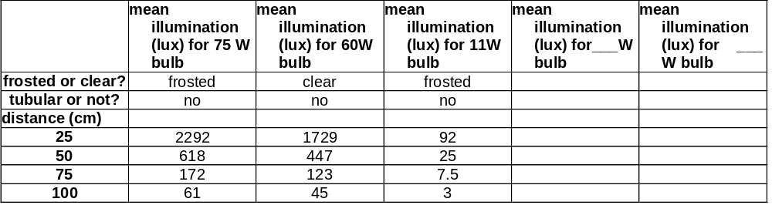

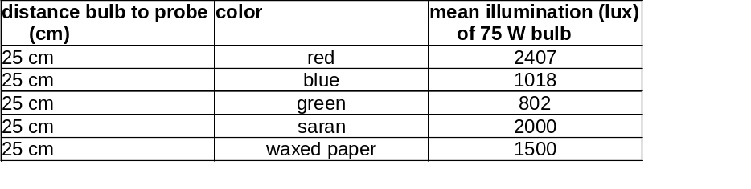

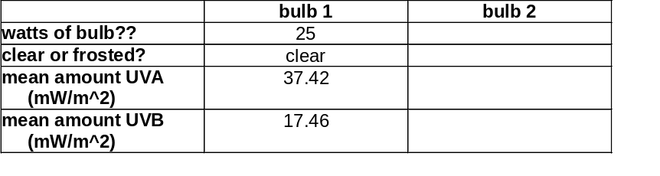

IMAGES:



