You are building a new roadway that will bypass your city. All toxic loads will be required to travel on this new bypass in order to lessen the chance of contamination to the local environment by accidents involving hazardous cargo. Your team will develop a recommendation for the development of the buffer zone beside the road.
Porosity:
To understand some of the factors involved, we will first study the porosity of materials. The porosity of earth materials is the percentage of the rock or soil that is void of material. We calculate this with the following equation:
$n=\frac{100V_{v}}{V}$ $n$= The total porosity of the material (%)
$V_{v}$ = The volume of the void space in the material (cm³)
$V$ = The volume of the earth material including solids and voids (cm³)
Supplies needed for this portion:
- Labeled samples of earth materials
- 100 ml graduated cylinder
- Plastic cup
- Your lab notebook
Procedure:
- Determine the volume of the cup.
- Fill the cup to the top with your assigned earth material.
- Using the 100 ml graduated cylinder, fill the container to the very top.
- Record the volume of the void spaces.
- Compute and record the porosity ($n$ ) of the material.
Note: 1 ml = 1 cm³
Sample | Volume of cup | Volume of void spaces | Porosity ($n$ )

Questions:
- What relationship did you discover between particle size and pore space?

- Do you think the porosity of earth materials will be a factor in lessening the chance of contamination of hazardous materials introduced into the local aquifer? Explain your answer.

Infiltration
Infiltration is the process of water moving from land into the soil. When water goes through a material, some of the water will drain from the material and some of the water will be retained by the material. Specific yield (S_{y}) is the ratio of water that drains from a saturated material by gravity to the total volume to the material. Specific retention (S_{r}) is the ratio of the volume of water that is retained or held in the materials against gravity to the total volume of rock. Recall the following equation for total porosity:
$$n=\frac{100V_{v}}{V}$$
Procedure:
- Repeat the procedures for porosity of 3 cups of your assigned material.
- Compute and record the porosity ($n$ ) of the material.
- Pour 1-2 of these cups of earth material into the filter apparatus, with a container below to catch the water draining by gravity.
- Record the volume of water drained by gravity.
- Compute S_{y} and S_{r}.
- Do not dump out the apparatus. You will need it for the next part.

Sample | Total volume of rock | Porosity ($n$ ) | Volume of water drained | Volume of water retained | Specific yield (S_{y}) | Specific retention (S_{r})

Questions:
- How might a high specific retention of an earth material help reduce the spread of a contaminant?

Aquifer Contamination

For this portion of the lab, you will calculate the years it will take for contamination X to naturally be removed from your earth material.

Procedure:
- Pour 100 ml of water into the system and allow it to flow through the system and collect in a clean clear cup.
- If your water flowing out of the system is not mostly clear, run water through the system until it is mostly clear. After it is mostly clear start keeping the 100 ml
- Have one group member fill a cuvette with your solution and test it with the UV/VIS Spectrometer, recording absorption for the wavelength assigned by your teacher.
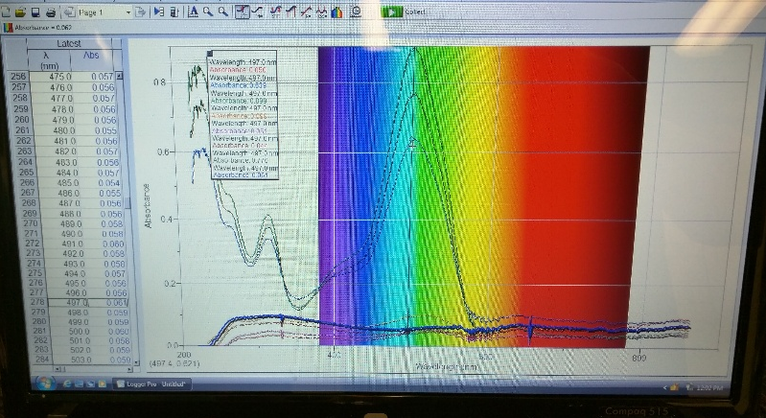
- Ask the teacher to add the contamination X to the filter apparatus with your gravity drained materials.
- Pour another 100 ml of water though the system collecting with a clean clear cup.
- Fill a cuvette with your new solution and run it through the UV/VIS.
- Repeat this process until all of the contamination has gone through the system.
- You should get a series of cups like the one below.
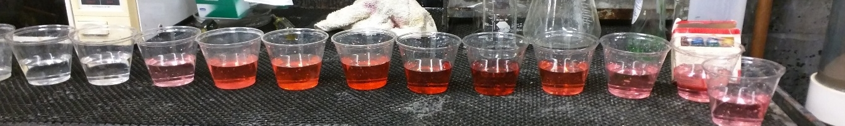
Run #

Absorbance

1 | 2 | 3 | 4 | 5 | 6 | 7 | 8 | 9 | 10
Absorbance

Run #

11 | 12 | 13 | 14 | 15 | 16 | 17 | 18 | 19 | 20

Questions:

- If each 100ml cycle represented a year of precipitation, how many years did it take for all of contamination X to run through the system? (Explain your answer)

- How might the porosity of the earth material affect the amount of time it takes for a contaminant to be naturally removed?

- How might we shorten the amount of time it would take to remove a contaminant for the ground?

Teacher notes:
Lab 1 Porosity:
- Remind students that they need to accurately determine the volume of the containers. Often time’s containers will have a volume on the bottom. However, this volume labeled is not for a completely full container.
- Make sure you have enough dry materials for each group for each class. If a group used wet material it will throw off the results.
- Set up a filter apparatus for each material and have students dump their cups in them to drain the water.
- Use a small bucket to have students rinse cups so that materials do not get in the sink drain.
- Set out rulers so that students may use them to scrap off the excess materials and get a full level cup of materials.
- After all groups have calculated Porosity, write them on the board so that the class can calculate an average.

Lab 2, Infiltration:
- Make sure you have enough dry materials for each group. The larger the containers your students use, the more materials you will need.
- The instructions explain how to calculate specific retention and specific yield. Some students will need this further explained.
- Gravel will flow through very fast and fine sand will travel very slowly. Use a coarse sand to have a nice rate.

Lab 3, Aquifer Contamination:
- Contamination X is whatever food coloring that you have in supply. 3 drops of a dark color of food coloring works nicely.
- Assign 2-3 groups to each earth material.
- Supplying pipets will make it easier for students to transfer liquids to the cuvette.
- Test the food coloring prior to class to see what nm the absorbance peaks. This is the wavelength that students will be recording.

