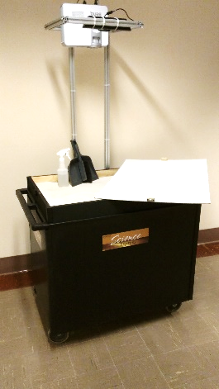
The Augmented Reality Sandbox
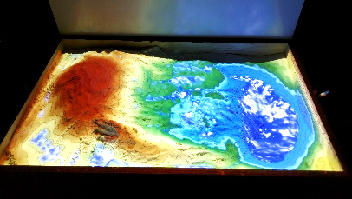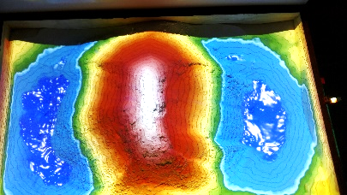

Do not unplug the power strip until the computer and projector have completely powered off
Set up:
- Plug the power strip in
- Turn on the projector
- Turn on the computer
- The visualization program should come up automatically and you should be ready to go.
Shut down:
- Shut off the projector by pressing the power button on the projector two times
- Shut off the computer by pressing the power button on the computer
- Wait for the both to fully shut down. The projector will have a loud beep when it is finished cooling down and shutting off.
- Turn the power strip off
- Unplug the power strip.
Trouble shooting:
- The topo lines are not there and the image is not clear.
  - Take the cap off of the projector.
- I’m getting a blue (or black) screen projected.
  - Restart the computer using the power button on the computer.
- The topo lines are not in the correct placement.
  - Carefully and gently adjust the Kinect sensor.
Accessories supplied:
- Spray bottle
- Cloud
- Dustpan and brush

