How to Import the

Brightspace Standard CoS Course Template

In this guide, we're going to go through how to import the standard College of Science course template into Brightspace.

To begin, download the course import file from the website.

Remember where you saved the file.

# Importing the Brightspace Export Package

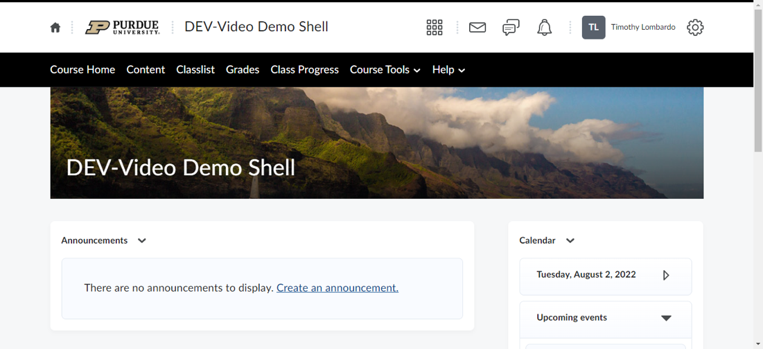

Make sure that you are in a development shell or the course shell that you want to import the course template into.

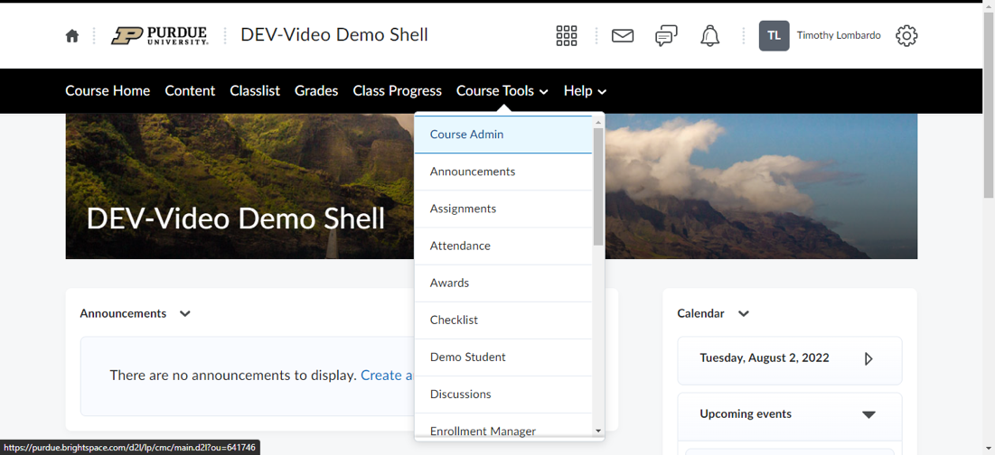

Click on “Course Tools” and then click on “Course Admin.”

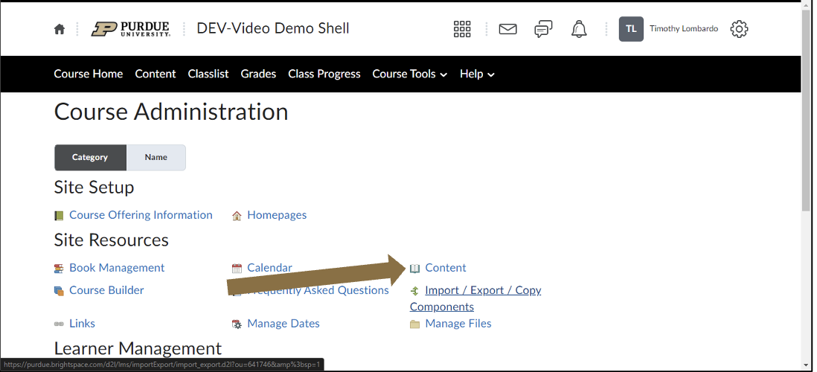

On this screen, scroll down and click on “Import, Export, Copy Components”

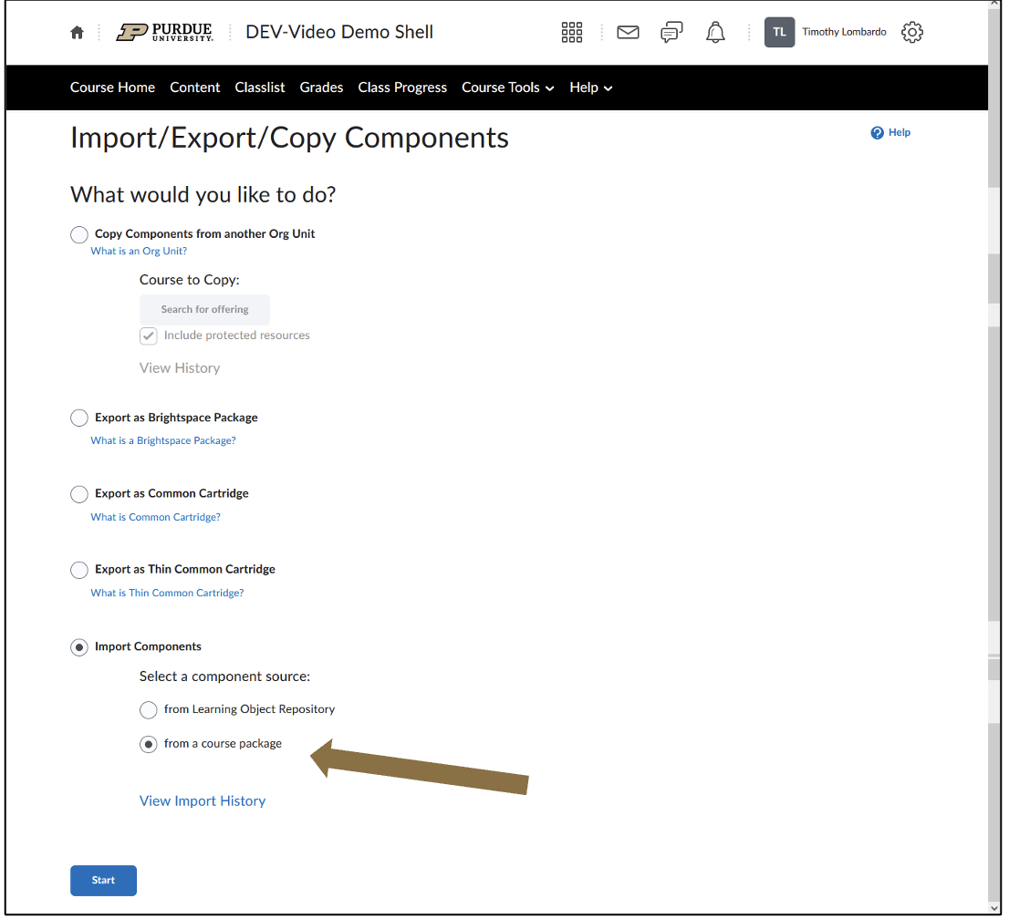

On this screen, scroll down and fill in the circle next to “import components.” Fill in the circle next to “from a course package”

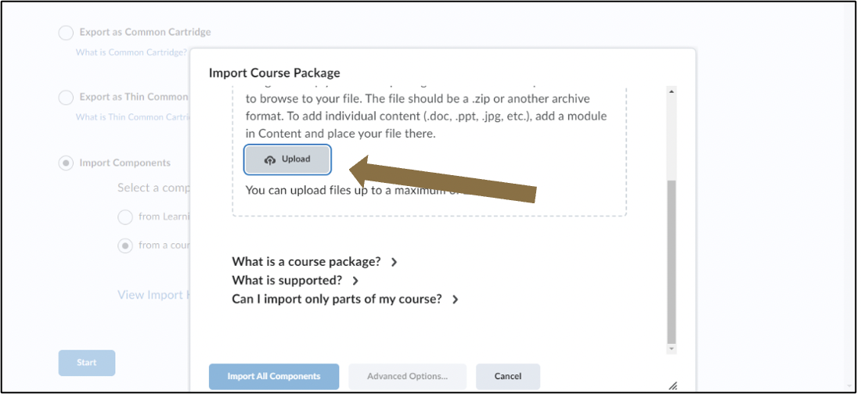

You can either **drag and drop the export package** right here, *or* you can **click on Upload button**.

Picture of a Brightspace screen showing the user to Browse to the file in the location that you previously saved the template file.

Either double-click on it file or click on the file and then click on the “open” button.

**If you click on Upload button**, you will be promopted to select the import file.

**Browse to the file in the location** where you saved the Brightspace template file.

**Either double-click on the file** or **click on the file once** and then **click on the “open” button**.

Picture of a Brightspace screen showing the user to The file will start importing, you'll see the bar move up and once it's a 100 percent, will have some more options.
Once the Brightspace package is imported, click on “Advanced Options.”

The file will start importing.

Once the Brightspace package has finished importing, **click on “Advanced Options.”**

Picture of a Brightspace screen showing the user to Next, the system is going to read the contents of the course package.
This should only take a few seconds.


Next, the system is going to read the contents of the course package.

This should only take a few seconds.

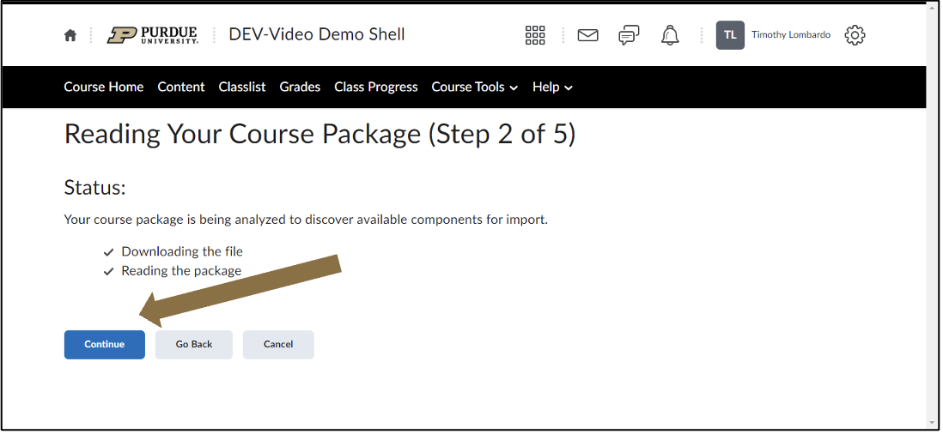

And then once it's ready, we have some more options. We're going to **click on Continue.**

# Selecting Components to Import

Picture of a Brightspace screen showing the user to We are going to go through the steps of selecting components.
First, place a check mark in the box to the left of “Select all components.”
Next, fill in the circle to the left of “Select individual items to import” for each category.
Scroll down and select the following:
Fill in the circle to the left of “Do not overwrite the existing file”
Place a check mark in the box to the left of “import metadata.”
Click on the Continue button.

Here are the steps to select components.

First, place a **check mark** in the box to the left of **“Select all components.”**

Next, **fill in the circle to the left** of **“Select individual items to import”** *for each category*.

Scroll down and select the following:

**Fill in the circle to the left** of **“Do not overwrite the existing file”**

Place a **check mark** in the box to the left of **“import metadata.”**

Click on the **Continue button**.

## Select Content Modules and Topics to Import

Picture of a Brightspace screen showing the user to First, we are going to select the content modules and topics to import.
Always select the following by place a check mark in the box to the left of:
For Instructors Only
Take the Academic Integrity at Purdue Acknowledgment
Take the Getting Started Syllabus Quiz.

Next, select either all the weeks or modules depending on how you teach your course
When you are finished, click on the Continue button.

First, select the content modules and topics to import.

Always select the following by place a **check mark** in the box to the left of:

**For Instructors Only**

**Take the Academic Integrity at Purdue Acknowledgment**

**Take the Getting Started Syllabus Quiz.**

Next, select either all the weeks or modules depending on how you teach your course

When you are finished, click on the **Continue button**.

## Select Rubrics to Import

Picture of a Brightspace screen showing the user to Next, we are going to select the Rubrics to import.
Select place a check mark in the box to the left of “Select All.”
When you are finished, click on the Continue button.

Next, select the Rubrics to import.

Select place a **check mark** in the box to the left of **“Select All.”**

When you are finished, click on the **Continue button**.

## Select Question Collection Items to Import

Picture of a Brightspace screen showing the user to Next, we are going to select survey questions to import.
Select place a check mark in the box to the left of “Select All.”
When you are finished, click on the Continue button.

Next, select survey questions to import.

Select place a **check mark** in the box to the left of **“Select All.”**

When you are finished, click on the **Continue button**.

## Select Quizzes to Import

## Picture of a Brightspace screen showing the user to Next, we are going to select Quizzes to import. Select place a check mark in the box to the left of “Select All.” When you are finished, click on the Continue button.

Next, select Quizzes to import.

Select place a **check mark** in the box to the left of **“Select All.”**

When you are finished, click on the **Continue button**.

## Select Discussion Forums and Topics to Import

Picture of a Brightspace screen showing the user to Select the following by place a check mark in the box to the left of:
Introduce Yourself
Learner Lounge
Next, select either all the weeks or modules depending on how you teach your course
When you are finished, click on the Continue button.

Select the following by place a **check mark** in the box to the left of:

**Introduce Yourself**

**Learner Lounge**

Next, select either all the weeks or modules depending on how you teach your course

When you are finished, click on the **Continue button**.

## Select Announcements to Import

Picture of a Brightspace screen showing the user to Next, we are going to select Announcements to import.
Select place a check mark in the box to the left of “Select All.”
When you are finished, click on the Continue button.

Next, select Announcements to import.

Select place a **check mark** in the box to the left of **“Select All.”**

When you are finished, click on the **Continue button**.

## Select Assignment Submission Folders to Import

Picture of a Brightspace screen showing the user to Next, we are going to select Assignment Submission Folders to import.
Select place a check mark in the box to the left of “Select All.”
When you are finished, click on the Continue button.

Next, select Assignment Submission Folders to import.

Select place a **check mark** in the box to the left of **“Select All.”**

When you are finished, click on the **Continue button**.

## Select Surveys to Import

Picture of a Brightspace screen showing the user to This area is optional.
These surveys allow you to get a pulse of what is happening with your students on a more frequent basis over just that final survey.
Select either all the weeks or modules depending on how you teach your course.
When you are finished, click on the Continue button.
If you don’t want to add these to your course, you can click on the Continue button without selecting any surveys.

**This area is optional.**

These surveys allow you to get a pulse of what is happening with your students on a more frequent basis over just that final survey.

Select either all the weeks or modules depending on how you teach your course.

When you are finished, click on the **Continue button**.

If you don’t want to add these to your course, you can click on the **Continue button** without selecting any surveys.

## Select Navigation to Import

Picture of a Brightspace screen showing the user to Next, we want to choose the theme of the course.
Select only one of the “Purdue West Lafayette Campus Theme.”
When you are finished, click on the Continue button.

Next, we want to choose the theme of the course.

Select only one of the **“Purdue West Lafayette Campus Theme.”**

When you are finished, click on the **Continue button**.

## Select External Learning Tools to Import

Picture of a Brightspace screen showing the user to This area is optional.
You can add a test video to see what they will look like in your course.
When you are finished, click on the Continue button.
If you don’t want to add these to your course, you can click on the Continue button without selecting any of the test videos.


**This area is optional.**

You can add a test video to see what it will look like in your course.

When you are finished, click on the **Continue button**.

If you don’t want to add these to your course, you can click on the **Continue button** without selecting any of the test videos.

## Select Course Appearance to Import

Picture of a Brightspace screen showing the user to Next, we are going to select Course Appearance to import.
Select place a check mark in the box to the left of “Select All.”
When you are finished, click on the Continue button.


Next, select Course Appearance to import.

Select place a **check mark** in the box to the left of **“Select All.”**

When you are finished, click on the **Continue button**.

# Confirming Your Selections

Picture of a Brightspace screen showing the user to This is a summary all the components that are being imported.
Go through and ensure that everything looks good.
Scroll down and select the following:
Fill in the circle to the left of “Do not overwrite the existing file”
Place a check mark in the box to the left of “import metadata.”
When you are finished, click on the Continue button.



This is a summary all the components that are being imported.

Go through and ensure that everything looks good.

Scroll down and select the following:

**Fill in the circle to the left** of **“Do not overwrite the existing file”**

Place a **check mark** in the box to the left of **“import metadata.”**

When you are finished, click on the **Continue button**.

# Automated Import Process

Picture of a Brightspace screen showing the user to Brightspace will being the importing process.
This is an automated process and may take a few minutes to import.


Brightspace will being the importing process.

This is an automated process and may take a few minutes to import.

# Confirming a Successful Import

Picture of a Brightspace screen showing the user to Once the import is complete, you have three green check marks.
Once you have three green checkmarks. click on the View Content button.



Once the import is complete, you have three green check marks.

Once you have three green checkmarks. click on the **View Content button**.

# View Imported Content

Picture of a Brightspace screen showing the user to After clicking on the View Content button, you will be taken to the content of the course.
You can now go through and start building your new online course!


After clicking on the **View Content button,** you will be taken to the content of the course.

You can now go through and start building your new online course!