DAS and SCIENCE EXPRESS EXPERIMENT: DETECTING BIOTECH CORN
EXPERIMENTAL PROCEDURE
Purpose: To detect a traited (GMO) corn plant using biotechniques including PCR and Gel Electrophoresis.
PCR Protocol: Day 1
Reagents and Supplies
Reagents:
- PCR master mix I (green)
- PCR master mix II (purple)
- GMO Positive DNA control (red)
- GMO Negative DNA control (blue)
- Genomic Corn DNA 1µg/µl (yellow)
- Unknown Corn DNA- 1 (yellow)
- Unknown Corn DNA- 2 (yellow)
Supplies:
- Thermocycler
- PCR tubes – strip tubes
- P200 Micropipette and tips
PCR Set-up:
Step 1: Remove master mixes and DNA tubes from freezer and allow to thaw on ice, once thawed, spin briefly in a micro centrifuge
Step 2: Label the PCR strip tubes as appropriate and micropipette the corresponding amounts
into the correctly labeled tubes. Microfuge the tubes for 1min; or Shake down gently

Tube # Master Mix DNA
1 30 µL MMI 20 µL Unknown DNA 1
2 30 µL MMI 20 µL Unknown DNA 2
3 30 µL MMI 20 µL GMO + DNA
4 30 µL MMI 20 µL GMO - DNA
5 30 µL MMI 20 µL water
Step 2b: If desired, set up another set of tubes using MMII
PCR Set-up: continued
Step 3: Program the thermocycler with the following conditions
PCR Parameters:
CYCLE | TEMP (⁰C) | TIME
Initial Denaturation | 96 | 10 minutes
Denaturation | 95 | 30 sec
Annealing | 58 | 30 sec  40 cycles
Elongation | 72 | 1 minute
Final Elongation | 72 | 10 minutes
Cool down | 4 | forever

- Add strip tubes to thermocycler, tighten lid, and start program
- After PCR program is completed, spin down and store at 4⁰C until use
Instruction:
- Explain basic principles of PCR and the components in the master mix and the purpose of each component
  - Primers specific for WT- corn gene called Invertase
  - Primers specific for inserted gene, called CamV35S Promoter
  - PCR Buffer including MgCl₂, the importance of pH
  - Taq polymerase enzyme

- Explain Thermocycling conditions and what is happening during cycles
  - Denaturation
  - Annealing – How is this temperature derived
  - Elongation
  - Log Phase of Amplification

- Explain a Biplex PCR and the expected results.
  - Internal control gene is a gene in which every corn plant has in their genome. The positive, negative control DNA and Unknown samples should have a band at 98bp.
  - If traited (GMO) corn, a second band should be detected. This band represents the gene which was inserted into the corn genome.
    - In MMI: the band size is ~150bp
    - In MMII: the band size is ~450bp
Gel Electrophoresis: Day 2
Reagents and Supplies
Reagents
- Molecular Weight Ladder
  - (1 Kb Plus or Promega 2-Log DNA ladder, 0.1ml, cat# N3200S)
- 5x Loading dye
- Agarose
- 1xTAE Buffer, dilute 10x TAE buffer (mol bio grade, 1L, cat# V4271)
- SYBR Safe Dye (cat# 533102)
or
- Fast Blast DNA Stain (500x) (Bio-Rad cat# 166-0420EDU)
- PCR Amplified Product
Supplies
- Electrophoresis rig with casting tray
- Power supply
- Balance
- Glassware – bottle or flask (heating Agarose)
- Graduated Cylinder
- Microwave – heating Agarose
- Staining tray – Fast Blast Stain
- Gel Imaging system (optional if using Fast Blast Dye)
- Micropipette – P10 and P200
Gel Electrophoresis Set-up Protocol
Making Agarose Gel: For a 1.2% Agarose gel:
Step 1: Weigh out .9 grams of Agarose and place into a glass container (bottle/flask).
Step 2: Using a graduate cylinder, measure 75mls of 1xTAE buffer and pour into glass container. (Dilute 10xTAE buffer with water to a 1xTAE solution)
Step 3: Heat in microwave to boiling point, but do not boil over. Swirl container and ensure all Agarose has gone into solution
Step 4: Allow to cool ~ 5-10 minutes
  - For SYBR Safe Stain: Add 7.5µL of SYBR stain into the Agarose and swirl
  - For Fast Blast Stain: Add 1µL of 500x Fast Blast DNA Stain into the Agarose and swirl

Gel Electrophoresis: Day 2 continued
Gel Rig Set-up:
Step 1: Ensure the casting tray is sealed and add the appropriate size comb, at least 8 wells
Step 2: Once Agarose is cooled to touch, pour slowly into the casting tray. Avoid bubbles.
Step 3: Allow Agarose to fully solidify (~ 10-15 min)
Step 4: Place Agarose gel with tray into the gel rig, remove the comb.
Step 5: Pour 1xTAE buffer over the gel and into the Electrophoresis chamber until the gel is fully submerged and the wells are covered. The gel is ready to load.
Note: If gel will be saved for next day loading, remove comb and slide off casting tray.
Wrap gel in Saran wrap and store in refrigerator. Begin next day with Step 4

Sample Preparation for Gel Loading: (while Agarose Gel is solidifying)
Step 1: Remove PCR products from refrigerator or thermocycler, quick spin in a micro centrifuge and ensure all contents are at the bottom of the tube
Step 2: Pipette 2µL of 5x Loading dye into each PCR sample tube, use a new pipette tip for each sample. Gently pipette up and down to mix the sample and dye. Quick spin samples.
Step 3: Prepare the Molecular Weight Ladder into a microfuge tube and label as Tube 6
- For 1Kb plus ladder: 28µL ladder + 2µL 5x Loading dye
Step 4: Prepare Genomic Corn DNA sample (optional), and label as Tube 7
- Pipette 25µL of 1µg of Corn DNA (tube 0) + 5 µL 5x Loading dye

Step 5: Load 30µL of each Sample onto the gel in the following order
Lane# Sample Load Volume
1 PCR Tube 1, Unknown DNA 1, MMII 30µL
2 PCR Tube 2, Unknown DNA 2, MMII 30µL
3 PCR Tube 3, GMO + Control, MMII 30µL
4 PCR Tube 4, GMO - Control, MMII 30µL
5 PCR Tube 5, water blank 30µL
6 Tube 6, Molecular weight ladder 30µL
7 Tube 7, Genomic Corn DNA 30µL
8 Blank or 5µL 5xLoading Dye 5µL

NOTE: Samples maybe prepped then stored in the refrigerator to load the next day

Gel Electrophoresis: Day 2 continued

Step 6: Plug Electrophoresis into power supply, set Voltage for 110 Volts for at least 30 min.
This is a guideline, time and voltage may vary depending on type and size of gel.
NOTE: Always remember “Run to Red”, (Negative to Positive)
Step 7: If used a SYBR Safe gel stain, (No Post Staining is Required)
- View gel with a UV-Illuminator with the following settings examples
(dependent upon type of imagining system)
  - 530 nm Emission filter; Excitation, broadband UV (VersaDoc Bio-Rad)
  - 530 nm Emission filter; Excitation 402nm (Gel Doc XR+, Bio-Rad)
  - 530 nm Emission filter; Excitation Blue Light, 480nm (Vernier)

Gel Staining Protocol (for Fast Blast DNA Stain) Day 3
Step 1: Remove gel from gel tray and gently slide into staining tray
Step 2: Make .1x dilution of 500x Fast Blast DNA stain
- For 200 mls: Micropipette 40µL of 500x Stain into 200mls DI water
Step 3: Pour Fast Blast dilution into staining tray and ensure entire gel is covered.
Place on rocker with low speed (40-60 rpm) overnight.
Bands will appear visual to eye

Explanation of Results

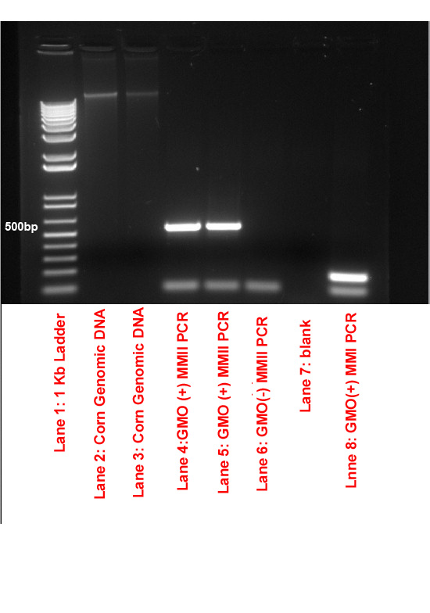

Discussion Points:
- Difference between genomic DNA and PCR Amplified DNA
- Fail results between a negative result
- Difference between positive band sizes

